# Parallelized Solution of 2D Laplacian using PETSc

Josh Bevan

3/25/14

22.602, Special Topic: Thermo-Fluids

# Abstract

Many physical phenomena can be modeled using Partial Differential Equations (PDEs). Most of these PDEs do not possess ready analytic solutions. The only computational alternative is numerical solution. It is common to arrive at a system of equations as a solution of the discretized numerical approximation to the PDE. These systems can be very large and computationally intensive to solve. The Portable, Extensible Toolkit for Scientific Computation (PETSc) is one tool available that uses parallelization techniques to solve these numerical problems on multiple processors concurrently. This offers the benefit of reduced run time, or increased accuracy/fidelity for the same run time compared to serial methods.

# Introduction

Laplace’s equation is a second-order homogenous linear partial differential equation. It models diffusive physical processes like heat conduction. A common solution technique to arrive at a numerical solution is the Finite Element Method (FEM). The FEM discretizes the domain into finitely many elements. The solution is represented on each element by a set of piecewise continuous polynomials. The residual of the equation is required to be orthogonal to a space of test functions who share a common basis with the numerical approximation of the solution.

From this discretization procedure a linear system of equations is recovered. In order for the problem to be well posed, boundary conditions must be imposed. Once fully formulated the system can be represented by Ax=b, with forcing b, numerical solution x, and stiffness matrix A.

This system of equations must now be solved by some means. In this project PETSc is used to assemble the matrix and vectors, as well as solve the system, using parallel methods on multiple processors/cores to accelerate solution times.

Contents

Parallelized Solution of 2D Laplacian using PETSc 1

Abstract 1

Introduction 1

Objectives 3

Theory 3

Derivation of Weak Form 3

Stability of Method 3

Choice of Basis Function 4

Discretization of Weak Form 4

Boundary Conditions 5

Local Elemental Matrix Construction 5

Recovery of Global Matrix 6

Application Details 6

General Solution Procedure 6

Useful Functions 7

Implementation 7

Results 9

Satisfactory Solution 9

Performance Scaling 11

Convergence 11

Ill Conditioned Node Numbering, Effects on Parallelizability 12

Conclusions 13

Recommendations for Further Study 13

Bibliography 13

Appendix A 1

Makefile Entry 1

Source Code 1

Mesh Generation and Node Order Conditioning 7

Example “-log_summary” 8

Parallel Scalability Logs 10

PETSc Installation Walkthrough 12

# Objectives

The primary objectives of this directed study/report are:

-to gain a working familiarity with the PETSc environment and tool-chain

-develop an unstructured FEM solver

-solve Laplace’s equation for various domains/BCs

-implement the solver using the PETSc environment to permit expansion to parallel operation

-solve Laplace’s equation using the unstructured solver implemented in PETSc

-validate solution and investigate convergence

-investigate parallelizability of the solver implemented

-investigate scalability of PETSc for large DOF systems of similar nature

# Theory

## Derivation of Weak Form

The strong form of the potential flow equation is given by (1) with boundary conditions (2):

$∇²u=0$ (1)  
 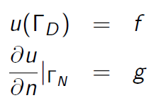 (2)

Multiplying by a weighting function and integrating over the domain yields (3):

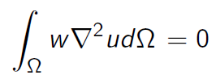 (3)

Using Green’s theorem and substitution of similar problem variables yields (4):

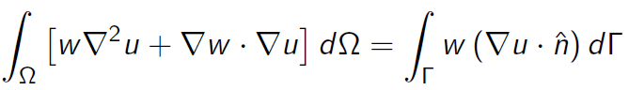 (4)

To satisfy the potential equation, the $w∇²u$ term in (4) is zero; rearranging yields (5), the weak form of (1):

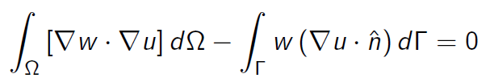 (5)

## Stability of Method

For a non-dimensionalized unit mass, kinetic energy is given by (6), and for the whole domain by (7):

$\frac{1}{2}u²=\frac{1}{2}∇ψ∙∇ψ$ (6)

${KE}_{domain}=\int{\int{\frac{1}{2}∇ψ∙∇ψ}} dΩ$ (7)

A perturbation to the potential flow *w*, adds additional kinetic energy to the domain, calculated in (8), (9), and (10):

${KE}_{domain}=\int{\int{\frac{1}{2}∇(ψ+w)∙∇(ψ+w)}} dΩ$ (8)

$=\int{\int{\left(\frac{1}{2}∇ψ∙∇ψ\right)+(∇ψ∙∇w)+(\frac{1}{2}∇w∙∇w)}} dΩ$ (9)

$=\int{\int{{KE}_{ψ}+{KE}_{w}+(∇ψ∙∇w)}} dΩ$ (10)

The kinetic energy due to the perturbative field must be greater than zero, unless the perturbation is trivially zero. No such explicit imposition is placed on the $(∇ψ∙∇w)$ term. Therefore minimizing the kinetic energy in the domain entails finding the configuration that sets $\left(∇ψ∙∇w\right)=0$, precisely the approach taken by FEM in (5).

## Choice of Basis Function

Figure 1 represents graphically the nodal linear hat functions: Green indicates lines in the x-y plane, red represents vertical lines (parallel to the z-axis), and blue indicates lines in a non-specific direction not in the x-y plane. All red lines are 1 unit tall, all nodes are on the x-y plane. All three elements in b) are the same identical element, with each basis function indicated for each node. The z-value of the function of a point on the plane defined by the two blue vectors indicates the value of the basis function from at a point in the x-y plane correlated with the projection of that point onto the x-y plane.

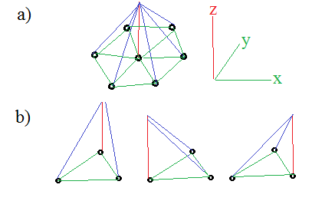

Figure 1: Graphical representation of linear hat functions

## Discretization of Weak Form

Equation (5) can be discretized in general by substituting in the appropriate functions for the weighting function and test function (11):

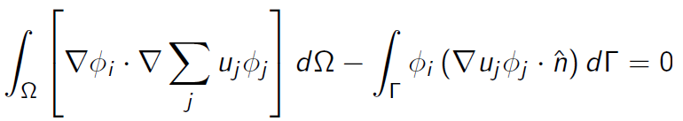 (11)

If the basis function is described as a plane as indicated in Figure 1, its equation can be parameterized as ax+by+c = z. The divergence of this function is given by (12):

$∇ϕ=a\vec{i}+b\vec{j}$ (12)

Therefore using (11) and (12) an individual node would be given by (13) for a node i and basis function from j:

$u_{i}\left(∇ϕ_{i}∙∇ϕ_{j}\right)= u_{i}(a_{i}a_{j}+b_{i}b_{j})$ (13)

## Boundary Conditions

As given in the first equation of (1) the Dirichlet BC is an explicit setting of the value of *u* at that boundary node. This simply involves insertion of an explicit ‘1’ at Ai,i  and zeroing the rest of that row. This implicitly gives the relation as given in (14):

$u_{i}=f_{i}$ (14)

Neumann BCs involve more derivation, but less assembly work; At the boundary the discrete weak form from (11) with a BC ‘f’, is given by (15):

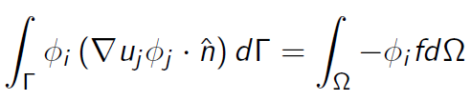 (15)

where the weighting basis function for the BC on the boundary is 1. $∇u_{i}∙\hat{n }=\frac{∂u}{∂n}$ is precisely the Neumann BC. Examining at a particular node *i,* with‘m’ nodes connected by elements locally numbered 1-m (mappable to their actual global node numbers), using (15) and applying the relation in (13) yields (16): 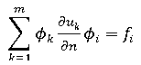 (16)

This is satisfied naturally by the FEM with no modification of the ‘A’ matrix required other than to insert the desired BC value at $f_{i}$.

## Local Elemental Matrix Construction

Using the discrete form from (11) and applying the relation between the basis functions in (13) at an element with local node numbers 1-3 (which correspond to mappable global node numbers) yields the elemental matrix (17):

$\int{\int{∇ϕ_{i}∙∇ϕ_{j} dΩ}}=\left[\begin{matrix}a_{1}a_{1}+b_{1}b_{1} & a_{1}a_{2}+b_{1}b_{2} & a_{1}a_{3}+b_{1}b_{3} \\ a_{2}a_{1}+b_{2}b_{1} & a_{2}a_{2}+b_{2}b_{2} & a_{2}a_{3}+b_{2}b_{3} \\ a_{3}a_{1}+b_{3}b_{1} & a_{3}a_{2}+b_{3}b_{2} & a_{3}a_{3}+b_{3}b_{3}\end{matrix}\right]$ (17)

The RHS can be isolated from (15) and with some modifications can be adapted to an elemental form (18), where m indicates indexing by local node number:

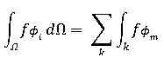 (18)

Modifying (18) gives the matrix value at a single node, using the area of a tetrahedron gives (19):

$\frac{1}{3}A_{o}\sum_{m=1}^{3 }{f_{m}ϕ_{m}}$ (19)

The basis function is a plane uniquely defined by the three points on its surface. This creates a system of equations that can be solved simultaneously. The solution for the basis function for local node 1 in matrix form is (20):

$\left[\begin{matrix}x_{1} & y_{1} & 1 \\ x_{2} & y_{2} & 1 \\ x_{3} & y_{3} & 1\end{matrix}\right]\left[\begin{matrix}a_{1} \\ b_{1} \\ c_{1}\end{matrix}\right]=\left[\begin{matrix}1 \\ 0 \\ 0\end{matrix}\right]$ (20)

A set of equations exists for each of the three basis functions in the element. Each one can be solved for the ‘a’ and ‘b’ coefficients and used to calculate (17) with the gradients calculated using (13).

## Recovery of Global Matrix

The local elemental node numbers correspond to global node numbers in the ‘A’ matrix. Therefore the locally produced elemental matrix from (17) must be mapped to the correct ‘A’ rows. Rows of order $ϕ_{i}$ are formed with their respective columns dictated by $ϕ_{j}$.

For instance suppose local i=1 node corresponds to 12, i=2 to 14, and i=3 to 27. Then the second row of (17) would be inserted into A(14,12), A(14,14), and A(14,27) moving column-wise from left to right. Likewise the other two rows would be inserted into the correct row dictated by $ϕ_{i}$.

One important consequence of this elemental stamping procedure is that if the surface isn’t homogenously tessellated, then some rows in the A matrix will contain more entries then others if they are more connected to other local nodes as all of them will have stamped their respective entries into that nodes row.

# Application Details

## General Solution Procedure

Generate immersed shape and nodes.

Generate the domain limits and node spacing

Perform a triangular meshing of the surface

for: each element

calculate connected node numbers and x-y locations

calculate triangular bounded area

calculate planar coefficients for elemental basis functions

calculate value of gradient dot products and assemble elemental matrix

calculate elemental forcing values

stamp elemental stiffness and forcing matrices into ‘A’ and ‘F’ matrices

end

Apply Neumann BCs

Apply Dirichlet BCs

Solve matrices for ‘u’ matrix

Write solution vector to file

## Useful Functions

This section is intended to give a brief summary to the interested reader what PETSc functions are of particular importance in the coding and solution of Laplace’s equation. Obvious/necessary functions like VecCreate() and MatCreate() are omitted. The intention is to highlight niche functions.

-PetscOptionsGetInt() is useful for passing parameters at runtime to change setup variables/conditions.

-MatZeroRows() will zero an entire matrix row except for the main diagonal. This is useful for applying Dirichlet BCs

-KSPView() allows various KSP context information to be displayed (iterations, convergence, etc)

- PetscPrintf() is useful for displaying variable information in real-time. It is important to make sure and use the correct communicator as necessary.

## Implementation

The general solution procedure lays out the broad tasks required, this section is intended to touch upon the PETSc specific requirements that need to be fulfilled to follow the general solution procedure. See the source code in Appendix A for greater detail.

The solution and forcing vectors are created and partitioned across the N processors. The program allows PETSc to determine this partitioning. The mesh local to each processor is determined and this information is used to pre-allocate the parallel matrix. It is important to ensure that the localization of the matrix aligns with that of the vectors already defined.

Next the element-node connectivity, node locations, and boundaries are read in from an input file. Generally this mesh could come from any mesh program; in this case two meshes are used that were already used in two serial Matlab. The intention here was to validate the numerical solutions of the PETSc with the more straightforward Matlab codes.

The elemental stiffness matrix is now built: global node numbers are associated with a particular element and the nodal locations are determined. From the nodal locations the bounded area of the simplex is determined and the gradients of the basis functions are calculated. These are used to generate the elemental stiffness entries and then “stamped” into the global parallel matrix.

The global matrix is then assembled and boundary conditions applied. A KSP context is created and solution parameters defined (pre-conditioner, solution method, etc.) and then the global system is solved, yielding the approximate numerical solution. This is then output to file.

# Results

Several experiments were done to achieve the objectives. Validation was performed and compared to two serial codes. Investigation of scaling as a function of processor number was investigated for the parallel Laplace code developed. Convergence was investigated and verified to the expected 2nd order for the basis functions used. An investigation on the effect of “ill-conditioned “ node numbering was also done.

## Satisfactory Solution

Two serial Matlab codes were used for validation of the PETSc Laplacian solver. The first solves a situation analogous to potential flow around a circular cross section, as seen in Fig. 2 (mesh in Fig. 3). The serial code was based upon previous work done in Prof. Willis’ Numerical Methods for PDEs course. One benefit of comparing against this solver is it has a built in mesh generation routine. This was modified to produce input meshes that could be used in the PETSc solver as well. The PETSc code was run using this input mesh with the same BCs, and the approximate numerical solution was output to a data file. The PETSc data was then plotted in Matlab and the results agreed fairly well with the expected solution.



Figure 2: Potential Flow Analogue solution (linear Dirichlet BCs on top and bottom, 0 Neumann BCs on left/right/cylinder



Figure 3: Mesh used for solution in Fig. 2

The second serial code used for validation was the heat conduction analogue code provided by Prof. Trelles as an example of a generalized FEM solver. This code does not have the capability of generating a mesh, but one was provided as an input file. This mesh input file was also used in the PETSc solver and resultant solution agreed quite well the expected solution. This is likely due to partly to the better conditioned mesh with aspect ratios closer to 1.



Figure 4: Heat Conduction Analogue solution with grid, non-dimensionalized Dirichlet on circle/bottom and 0 Neumann on remaining boundary

## Performance Scaling

The potential flow grid generation tool was used to generate a grid of ~10k DOFs for the same domain/BCs already discussed. It was run several times for varying numbers of processors, with the results plotted in Fig. 5. It is important to note that for lower numbers of elements the scaling was actually minimal, or negative in the case of 1k DOFs. This is likely due to the communication overhead amongst processors. For small enough systems more work is done distributing work than actually doing it. (See Appendix A for some example performance logs of 10k).

Figure 5: Parallel scaling of Laplacian PETSc code developed for varying DOFs

## Convergence

In lieu of an exact solution for comparison, the KSPGetResidualNorm() was used to estimate convergence of the PETSc Laplacian solver with respect to grid refinement. This was performed for a range of refinements and the log-log of the results are plotted in Fig. 6. As is expected of a FEM with hat basis functions the convergence is ~2nd order.

Figure 6: Convergence of Laplacian solver for increasing grid refinement

## Ill Conditioned Node Numbering, Effects on Parallelizability

From the standpoint of minimizing inter-process communications in a parallel code, ideally the matrix would be partitioned in such a way so that with a given process most elements are local. PETSc has tools that can perform this task (DMDA and DMPLEX), but ultimately they were beyond the scope of what was attainable in the directed study. The mesh generator used in the potential flow solver is able to alleviate this somewhat by numbering nodes in such a way that nearby nodes are of approximately the same range.

When plotted the sparsity pattern is primarily triple banded, fairly well “conditioned” in the sense of localization. A modification of the mesh generation routine was made (See Appendix A) that “scrambled” the node numbering so that the sparsity pattern was now more or less random.

The Laplacian PETSc solver was then used to solve the same actual mesh as in the well-conditioned case, but now with the sparsity pattern nearly as unfavorable as one could hope. The results are plotted in Fig. 7. As can be seen, for the same grid the solution process took far longer. Additionally, the parallelism of the problem did not scale nearly as well.

Figure 7: Effect of ill-conditioned node numbering on parallelizability

# Conclusions

An unstructured FEM solver was implemented for the 2D Laplace’s equation using PETSc for matrix assembly and linear equation solving. The approximate numerical solutions were successfully validated against two Matlab serial codes. Scaling and convergence were investigated and found to meet reasonable expectations. Finally, some insight was developed on the nature of “conditioning” of node numbering on parallelism. It was found that absent a robust matrix partitioner, it is critical that nodes are labeled respecting locality.

# Recommendations for Further Study

There are several potentially interesting areas of further study. First, using PETSc methods that perform intelligent graph partitioning would likely add a great deal of robustness to the scalability of the code. Second, no attempt was made to exploit a priori knowledge of the matrix structure. PETSc has a great deal of pre-conditioners and solvers that if tailored to the problem may be more performant.

# Bibliography

[1] PETSc Users Manual, Revision 3.4, May 2013; Balay, Brown et. al.

# Appendix A

## Makefile Entry

Place after example KSP make entries in the KSP makefile (note tabs are contextual whitespace):

2DLJJB**:** 2DLJJB.o chkopts

-${CLINKER} -o 2DLJJB 2DLJJB.o ${PETSC_KSP_LIB}

${RM} 2DLJJB.o

## Source Code

/* Bevan, Josh UMass Lowell 2013-2014

*Developed with the help of Prof. Trelles, UMass Lowell

*In partial satisfaction of directed study 22.602 Fall 2013

*Solves the 2D Laplacian on an unstructured grid with KSP.*/

static char help**[]** **=** "Solves the 2D Laplacian on an unstructured grid with KSP. Bevan 2014\n\n"**;**

#include <petscksp.h>

#undef __FUNCT__

#define __FUNCT__ "main"

int main**(**int argc**,**char **\*\***args**)**

**{**

Vec x**,** b**;** /* approx solution, RHS*/

Mat A**;** /* linear system matrix */

KSP ksp**;** /* linear solver context */

PC pc**;** /* preconditioner context */

PetscReal norm**;** /* norm of solution error */

PetscErrorCode ierr**;**

PetscInt n **=** 81**;** /*Number of DOFs*/

/*For simplicity of use the mesh input file lengths need to be manually

*input here JJBLeft[],JJBRight[],JJBElems[], and JJBNodes[]*/

PetscInt row**[**9**],**col**[**9**],**its**,**elnd**[**3**],**JJBElems**[**384**],**iter**=**0**,**NbElems**,**NbVertices**;**

PetscInt numint**,**xx**=**0**,**yy**=**1**,**ie**,**rstart**,**rend**,**nlocal**,**NbBound**=**3**,**JJBLeft**[**3**],**JJBRight**[**3**];**

PetscScalar value**[**9**],**n1**[**2**],**n2**[**2**],**n3**[**2**],**gn1**[**2**],**gn2**[**2**],**gn3**[**2**],**A11**,**A22**,**A33**,**A12**,**A13**,**A23**;**

PetscScalar JJBNodes**[**162**],**numscal**,**TriArea**;**

PetscScalar LeftBC**[**3**],** RightBC**[**3**];** /*Dirichlet BC values, top

*and bottom domains implicitly Neumann=0*/

PetscViewer viewer**;**

PetscInitialize**(&**argc**,&**args**,(**char**\*)**0**,**help**);**

ierr **=** PetscOptionsGetInt**(NULL,**"-sizer"**,&**n**,NULL);**CHKERRQ**(**ierr**);**

/*----------------------------------------------------------------------*/

/* Create vectors. Create one vector and duplicate as needed.

* The second argument to VecSetSizes() below causes PETSc to decide

* how many elements per processor are assigned */

ierr **=** VecCreate**(**PETSC_COMM_WORLD**,&**x**);**CHKERRQ**(**ierr**);**

ierr **=** VecSetSizes**(**x**,**PETSC_DECIDE**,**n**);**CHKERRQ**(**ierr**);**

ierr **=** VecSetFromOptions**(**x**);**CHKERRQ**(**ierr**);**

ierr **=** VecDuplicate**(**x**,&**b**);**CHKERRQ**(**ierr**);**

/* Find start and end mesh points on each processor for the

* interior of the mesh. This partitioning is based upon

* the choices made for the vector in VecSetSizes()*/

ierr **=** VecGetOwnershipRange**(**x**,&**rstart**,&**rend**);**CHKERRQ**(**ierr**);**

ierr **=** VecGetLocalSize**(**x**,&**nlocal**);**CHKERRQ**(**ierr**);**

/*----------------------------------------------------------------------*/

/* Create matrix A with MatCreate(); matrix format can be

* specified at runtime

* Use nlocal as the local size of the matrix, this ensures it will

* align with the vectors from above */

ierr **=** MatCreate**(**PETSC_COMM_WORLD**,&**A**);**CHKERRQ**(**ierr**);**

ierr **=** MatSetSizes**(**A**,**nlocal**,**nlocal**,**n**,**n**);**CHKERRQ**(**ierr**);**

ierr **=** MatSetFromOptions**(**A**);**CHKERRQ**(**ierr**);**

ierr **=** MatSetUp**(**A**);**CHKERRQ**(**ierr**);**

/*----------------------------------------------------------------------*/

/*Read in mesh */

/*Read in elem/node associations*/

FILE **\***file **=** fopen**(**"JJBElems"**,** "r"**);**

**while(**fscanf**(**file**,** "%d"**,** **&**numint**)** **==** 1**)** **{**

JJBElems**[**iter**]** **=** numint**;**

iter**++;**

**}**

NbElems **=** iter**/**3**;**

fclose**(**file**);**

/*Read in vertex coordinates*/

FILE **\***file2 **=** fopen**(**"JJBNodes"**,** "r"**);**

iter**=**0**;**

**while(**fscanf**(**file2**,** "%lf"**,** **&**numscal**)** **==** 1**)** **{** /*Note %lf for doubles to match PetscScalar */

JJBNodes**[**iter**]** **=** numscal**;**

iter**++;**

**}**

NbVertices **=** iter**/**2**;**

fclose**(**file2**);**

/*Read in Left BC*/

FILE **\***file3 **=** fopen**(**"JJBLeft"**,** "r"**);**

iter**=**0**;**

**while(**fscanf**(**file3**,** "%d"**,** **&**numint**)** **==** 1**)** **{**

JJBLeft**[**iter**]** **=** numint**-**1**;**

iter**++;**

**}**

NbBound **=** iter**;**

fclose**(**file3**);**

/*Read in Right BC*/

FILE **\***file4 **=** fopen**(**"JJBRight"**,** "r"**);**

iter**=**0**;**

**while(**fscanf**(**file4**,** "%d"**,** **&**numint**)** **==** 1**)** **{**

JJBRight**[**iter**]** **=** numint**-**1**;**

iter**++;**

**}**

fclose**(**file4**);**

/*----------------------------------------------------------------------*/

/* Assemble matrix.

The linear system is distributed across the processors by

chunks of contiguous rows, which correspond to contiguous

sections of the mesh on which the problem is discretized.

For matrix assembly, each processor contributes entries for

the part that it owns locally. */

/* From manual: The routine MatSetValuesBlocked() may offer much

* better efficiency for users of block sparse formats

* (MATSEQBAIJ and MATMPIBAIJ) */

**for** **(**ie**=**0**;**ie**<**NbElems**-**1**;**ie**+=**3**){**

ierr **=** PetscPrintf**(**PETSC_COMM_WORLD**,**"JJB: ie: %D\n"**,**ie**);**CHKERRQ**(**ierr**);**

/*For each element find the associated node numbers */

elnd**[**0**]** **=** JJBElems**[**ie**]-**1**;**

elnd**[**1**]** **=** JJBElems**[**ie**+**1**]-**1**;**

elnd**[**2**]** **=** JJBElems**[**ie**+**2**]-**1**;**

/* Determine element node locations */

n1**[**xx**]** **=** JJBNodes**[**2**\***elnd**[**0**]];**

n1**[**yy**]** **=** JJBNodes**[(**2**\***elnd**[**0**])+**1**];**

n2**[**xx**]** **=** JJBNodes**[**2**\***elnd**[**1**]];**

n2**[**yy**]** **=** JJBNodes**[(**2**\***elnd**[**1**])+**1**];**

n3**[**xx**]** **=** JJBNodes**[**2**\***elnd**[**2**]];**

n3**[**yy**]** **=** JJBNodes**[(**2**\***elnd**[**2**])+**1**];**

/*Calculate bounded area*/

TriArea **=** abs**((** **(**n1**[**xx**]*(**n2**[**yy**]-**n3**[**yy**]))** **+** **(**n2**[**xx**]*(**n3**[**yy**]-**n1**[**yy**]))** **+** **(**n3**[**xx**]*(**n1**[**yy**]-**n2**[**yy**]))** **)/**2**);**

/*Calculate gradients:

* without the benefit of a low overhead linear solver these

* were algebraicly solved. The equivalent Matlab code is:

Plane = [X0 Y0 1;...

X1 Y1 1;...

X2 Y2 1];

Gradient(:,0) = Plane\[1;0;0];

Gradient(:,1) = Plane\[0;1;0];

Gradient(:,2) = Plane\[0;0;1];

Gradient(3,:) = 0; %Remove unwanted c coeff */

**if** **(**n2**[**yy**]!=**n3**[**yy**]){**

gn1**[**xx**]** **=** **-**1**/(** **(** **(**n2**[**xx**]-**n3**[**xx**])** **\*** **(**n1**[**yy**]-**n3**[**yy**])** **/** **(**n2**[**yy**]-**n3**[**yy**])** **)** **-** **(**n1**[**xx**]-**n3**[**xx**])** **);**

**}else{**

gn1**[**xx**]** **=** 0**;}**

**if** **(**n2**[**xx**]!=**n3**[**xx**]){**

gn1**[**yy**]** **=** **-**1**/(** **(** **(**n2**[**yy**]-**n3**[**yy**])** **\*** **(**n1**[**xx**]-**n3**[**xx**])** **/** **(**n2**[**xx**]-**n3**[**xx**])** **)** **-** **(**n1**[**yy**]-**n3**[**yy**])** **);**

**}else{**

gn1**[**yy**]** **=** 0**;}**

**if** **(**n1**[**yy**]!=**n3**[**yy**]){**

gn2**[**xx**]** **=** **-**1**/(** **(** **(**n1**[**xx**]-**n3**[**xx**])** **\*** **(**n2**[**yy**]-**n3**[**yy**])** **/** **(**n1**[**yy**]-**n3**[**yy**])** **)** **-** **(**n2**[**xx**]-**n3**[**xx**])** **);**

**}else{**

gn2**[**xx**]** **=** 0**;}**

**if** **(**n1**[**xx**]!=**n3**[**xx**]){**

gn2**[**yy**]** **=** **-**1**/(** **(** **(**n1**[**yy**]-**n3**[**yy**])** **\*** **(**n2**[**xx**]-**n3**[**xx**])** **/** **(**n1**[**xx**]-**n3**[**xx**])** **)** **-** **(**n2**[**yy**]-**n3**[**yy**])** **);**

**}else{**

gn2**[**yy**]** **=** 0**;}**

**if** **(**n1**[**yy**]!=**n2**[**yy**]){**

gn3**[**xx**]** **=** **-**1**/(** **(** **(**n1**[**xx**]-**n2**[**xx**])** **\*** **(**n3**[**yy**]-**n2**[**yy**])** **/** **(**n1**[**yy**]-**n2**[**yy**])** **)** **-** **(**n3**[**xx**]-**n2**[**xx**])** **);**

**}else{**

gn3**[**xx**]** **=** 0**;}**

**if** **(**n1**[**xx**]!=**n2**[**xx**]){**

gn3**[**yy**]** **=** **-**1**/(** **(** **(**n1**[**yy**]-**n2**[**yy**])** **\*** **(**n3**[**xx**]-**n2**[**xx**])** **/** **(**n1**[**xx**]-**n2**[**xx**])** **)** **-** **(**n3**[**yy**]-**n2**[**yy**])** **);**

**}else{**

gn3**[**yy**]** **=** 0**;}**

/*Calculate local elemental matrix*/

A11 **=** TriArea **\*** **(**gn1**[**xx**]\***gn1**[**xx**]** **+** gn1**[**yy**]\***gn1**[**yy**]);**

A22 **=** TriArea **\*** **(**gn2**[**xx**]\***gn2**[**xx**]** **+** gn2**[**yy**]\***gn2**[**yy**]);**

A33 **=** TriArea **\*** **(**gn3**[**xx**]\***gn3**[**xx**]** **+** gn3**[**yy**]\***gn3**[**yy**]);**

A12 **=** TriArea **\*** **(**gn1**[**xx**]\***gn2**[**xx**]** **+** gn1**[**yy**]\***gn2**[**yy**]);**

A13 **=** TriArea **\*** **(**gn1**[**xx**]\***gn3**[**xx**]** **+** gn1**[**yy**]\***gn3**[**yy**]);**

A23 **=** TriArea **\*** **(**gn2**[**xx**]\***gn3**[**xx**]** **+** gn2**[**yy**]\***gn3**[**yy**]);**

/*Create value array to be stamped*/

value**[**0**]** **=** A11**;**

value**[**1**]** **=** A12**;**

value**[**2**]** **=** A13**;**

value**[**3**]** **=** A12**;**

value**[**4**]** **=** A22**;**

value**[**5**]** **=** A23**;**

value**[**6**]** **=** A13**;**

value**[**7**]** **=** A23**;**

value**[**8**]** **=** A33**;**

/*Create global node index arrays for stamping*/

row**[**0**]** **=** elnd**[**0**];**

row**[**1**]** **=** elnd**[**1**];**

row**[**2**]** **=** elnd**[**2**];**

row**[**3**]** **=** elnd**[**0**];**

row**[**4**]** **=** elnd**[**1**];**

row**[**5**]** **=** elnd**[**2**];**

row**[**6**]** **=** elnd**[**0**];**

row**[**7**]** **=** elnd**[**1**];**

row**[**8**]** **=** elnd**[**2**];**

/*-*/

col**[**0**]** **=** elnd**[**0**];**

col**[**1**]** **=** elnd**[**0**];**

col**[**2**]** **=** elnd**[**0**];**

col**[**3**]** **=** elnd**[**1**];**

col**[**4**]** **=** elnd**[**1**];**

col**[**5**]** **=** elnd**[**1**];**

col**[**6**]** **=** elnd**[**2**];**

col**[**7**]** **=** elnd**[**2**];**

col**[**8**]** **=** elnd**[**2**];**

/* Stamp in local elemental matrix into global matrix of form: */

/*

A(N1, N1) = A(N1, N1) + A_elemental(1,1);

A(N2, N1) = A(N2, N1) + A_elemental(2,1);

A(N3, N1) = A(N3, N1) + A_elemental(3,1);

A(N1, N2) = A(N1, N2) + A_elemental(1,2);

A(N2, N2) = A(N2, N2) + A_elemental(2,2);

A(N3, N2) = A(N3, N2) + A_elemental(3,2);

A(N1, N3) = A(N1, N3) + A_elemental(1,3);

A(N2, N3) = A(N2, N3) + A_elemental(2,3);

A(N3, N3) = A(N3, N3) + A_elemental(3,3);*/

ierr **=** MatSetValues**(**A**,**9**,**row**,**9**,**col**,**value**,**ADD_VALUES**);**CHKERRQ**(**ierr**);**

**}**

/* Assemble the matrix */

ierr **=** MatAssemblyBegin**(**A**,**MAT_FINAL_ASSEMBLY**);**CHKERRQ**(**ierr**);**

ierr **=** MatAssemblyEnd**(**A**,**MAT_FINAL_ASSEMBLY**);**CHKERRQ**(**ierr**);**

/*----------------------------------------------------------------------*/

/* Apply BCs

* MatZeroRows allows easy application of Dirichlet BCs by zeroing all entries

* except the main diag (i.e. the self-reference needed to enforce BCs */

ierr **=** VecSet**(**b**,**0**);**CHKERRQ**(**ierr**);**

**for(**iter**=**0**;**iter**<**NbBound**;**iter**++){**

LeftBC**[**iter**]** **=** 2**;**

RightBC**[**iter**]** **=** 1**;**

**}**

ierr **=** MatZeroRows**(**A**,**NbBound**,**JJBLeft**,**1**,**0**,**0**);**CHKERRQ**(**ierr**);**

ierr **=** VecSetValues**(**b**,**NbBound**,**JJBLeft**,**LeftBC**,**INSERT_VALUES**);**CHKERRQ**(**ierr**);**

ierr **=** MatZeroRows**(**A**,**NbBound**,**JJBRight**,**1**,**0**,**0**);**CHKERRQ**(**ierr**);**

ierr **=** VecSetValues**(**b**,**NbBound**,**JJBRight**,**RightBC**,**INSERT_VALUES**);**CHKERRQ**(**ierr**);**

/*----------------------------------------------------------------------*/

ierr **=** KSPCreate**(**PETSC_COMM_WORLD**,&**ksp**);**CHKERRQ**(**ierr**);** /* Create linear solver context */

/* Set operators. A also serves as preconditioning matrix */

ierr **=** KSPSetOperators**(**ksp**,**A**,**A**,**DIFFERENT_NONZERO_PATTERN**);**CHKERRQ**(**ierr**);**

/* Set linear solver defaults for problem.

Extract KSP and PC contexts from the KSP context,

to directly call any KSP and PC routines to set options */

ierr **=** KSPGetPC**(**ksp**,&**pc**);**CHKERRQ**(**ierr**);**

ierr **=** PCSetType**(**pc**,**PCJACOBI**);**CHKERRQ**(**ierr**);**

ierr **=** KSPSetTolerances**(**ksp**,**1.e-7**,**PETSC_DEFAULT**,**PETSC_DEFAULT**,**PETSC_DEFAULT**);**CHKERRQ**(**ierr**);**

/* Set runtime options,

-ksp_type <type> -pc_type <type> -ksp_monitor -ksp_rtol <rtol>

These options will override those specified above as long as

KSPSetFromOptions() is called _after_ any other customization

routines */

ierr **=** KSPSetFromOptions**(**ksp**);**CHKERRQ**(**ierr**);**

ierr **=** KSPSolve**(**ksp**,**b**,**x**);**CHKERRQ**(**ierr**);** /* Solve linear system */

/*----------------------------------------------------------------------*/

ierr **=** KSPView**(**ksp**,**PETSC_VIEWER_STDOUT_WORLD**);**CHKERRQ**(**ierr**);** /* View solver info */

/* Check the error*/

ierr **=** KSPGetResidualNorm**(**ksp**,&**norm**);**CHKERRQ**(**ierr**);**

ierr **=** KSPGetIterationNumber**(**ksp**,&**its**);**CHKERRQ**(**ierr**);**

ierr **=** PetscPrintf**(**PETSC_COMM_WORLD**,**"JJB: Norm of error %G, Iterations %D\n"**,**norm**,**its**);**CHKERRQ**(**ierr**);**

/* Output solution vector to file for external plotting*/

ierr **=** PetscViewerASCIIOpen**(**PETSC_COMM_WORLD**,**"x.output"**,&**viewer**);**CHKERRQ**(**ierr**);**

ierr **=** VecView**(**x**,**viewer**);**CHKERRQ**(**ierr**);**

/* Free work space */

ierr **=** VecDestroy**(&**x**);**CHKERRQ**(**ierr**);**

ierr **=** VecDestroy**(&**b**);**CHKERRQ**(**ierr**);**

ierr **=** MatDestroy**(&**A**);**CHKERRQ**(**ierr**);**

ierr **=** KSPDestroy**(&**ksp**);**CHKERRQ**(**ierr**);**

/* PetscFinalize() before exiting program. Provides summary

* and diagnostic information if certain runtime options

* are chosen (e.g., -log_summary) */

ierr **=** PetscFinalize**();**

**return** 0**;**

**}**

## Mesh Generation and Node Order Conditioning

%Bevan 2014

%Simple mesh generation wrapper that ultimately uses Delaunay()

%triangulation. Ideally a mesh generator generates node

%numbering such that neighbouring nodes are close to each other

%in value.

%This script also optionally allows "scrambling" of node numbers

%To remove any "nice" banding of the A matrix to investigate

%its effect on PETSc parallel overhead

Shape **=** 1**;** %[1 0045];

DomainSize **=** 4**;**

ref **=** 2**;**

powerRef **=** 2**;**%getDiscreteGeometry is a function written by Prof. Willis UMass Lowell

**[**TRItemp**,** Nodestemp**,** Toptemp**,** Bottomtemp**,** Lefttemp**,** Righttemp**,** InnerBoundarytemp**]** **=** getDiscreteGeometry**(**Shape**,** DomainSize**,** ref**,** powerRef**);**

%Allow ranomization of node order to investigate sparse pattern

Nodes **=** Nodestemp**;**

TRI **=** TRItemp**;**

Top **=** Toptemp**;**

Bottom **=**Bottomtemp**;**

Left **=** Lefttemp**;**

Right **=** Righttemp**;**

InnerBoundary **=** InnerBoundarytemp**;**

**if** false %True for ranomization, false to leave mesh alone

Choices **=** 1**:**length**(**Nodes**);**

**for** i**=**1**:**length**(**Nodes**)**

Chooser **=** max**(**1**,**round**(**rand**(**1**)\***length**(**Choices**)));**

Chosen **=** Choices**(**Chooser**);**

Nodes**(**i**,:)** **=** Nodestemp**(**Chosen**,:);**

TRI**(**TRItemp**==**Chosen**)** **=** i**;**

Top**(**Toptemp**==**Chosen**)** **=** i**;**

Bottom**(**Bottomtemp**==**Chosen**)** **=** i**;**

Left**(**Lefttemp**==**Chosen**)** **=** i**;**

Right**(**Righttemp**==**Chosen**)** **=** i**;**

InnerBoundary**(**InnerBoundarytemp**==**Chosen**)** **=** i**;**

Choices **=** Choices**([**1**:**Chooser**-**1 **,** Chooser**+**1**:end]);**

**end**

**end**

Nodes **=** reshape**(**Nodes**',**1**,**numel**(**Nodes**))';**

dlmwrite**(**'JJBElems'**,**reshape**(**TRI**',**1**,**numel**(**TRI**)),** 'delimiter'**,** '\n'**);**

dlmwrite**(**'JJBLeft'**,**Left**,** 'delimiter'**,** '\n'**);**

dlmwrite**(**'JJBRight'**,**Right**,** 'delimiter'**,** '\n'**);**

save**(**'JJBNodes'**,**'Nodes'**,**'-ascii'**,**'-double'**);**

## C:\Users\jbevan\Documents\GitHub\PETSc-Directed-Study\Temp\2A.pngExample “-log_summary” C:\Users\jbevan\Documents\GitHub\PETSc-Directed-Study\Temp\1A.png

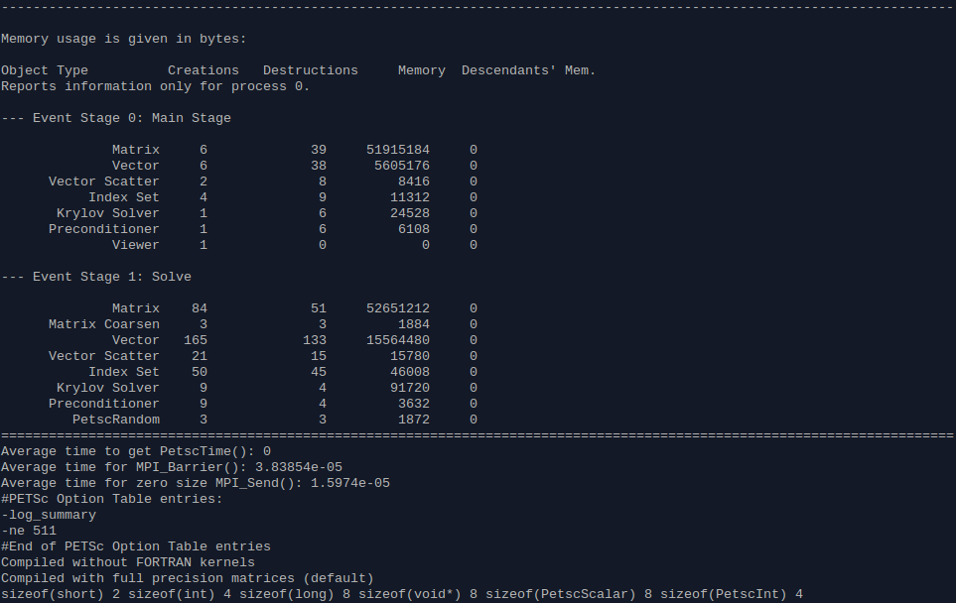

## Parallel Scalability Logs

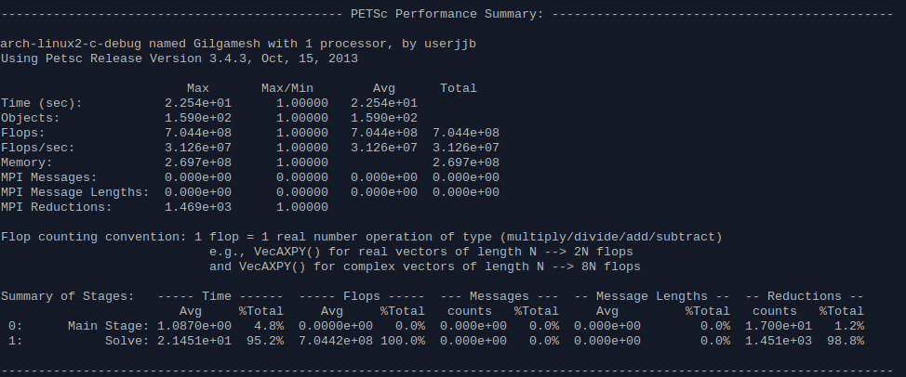

1 Processor

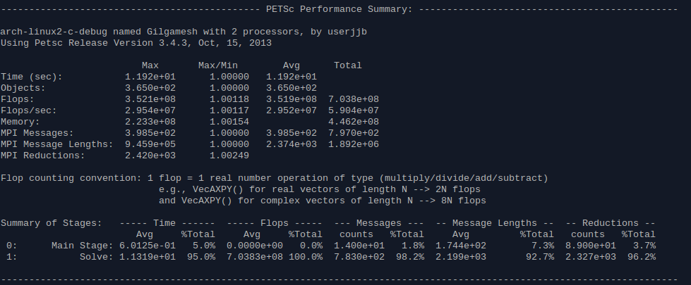

2 Processors

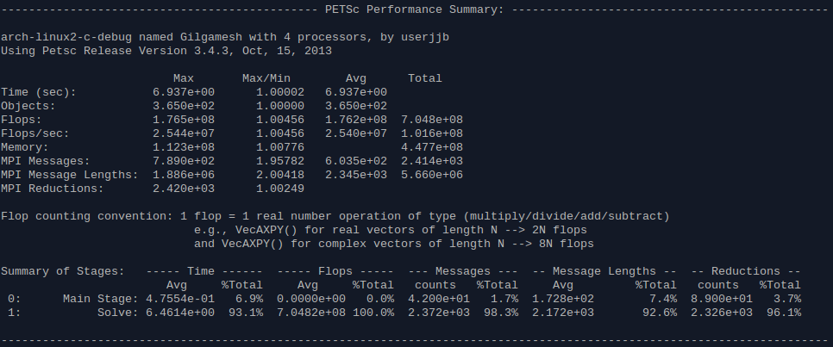

4 Processors

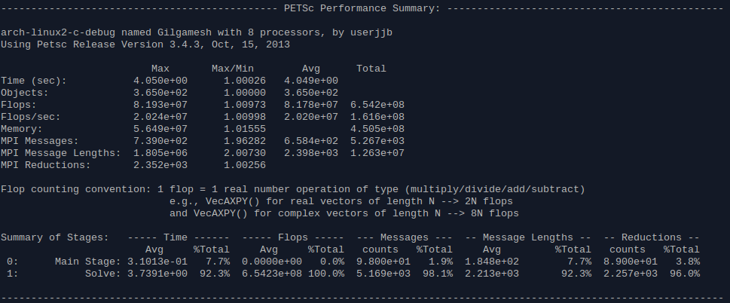

8 Processors

## PETSc Installation Walkthrough

This is for 64-bit Xubuntu 13.04 on a x86-64 system. You will need [Python](http://www.python.org/), [valgrind](http://valgrind.org/),[gdb](http://www.sourceware.org/gdb/), [gfortran](http://gcc.gnu.org/wiki/GFortran), and C/C++ compilers. In my case I chose [Clang](http://clang.llvm.org/) for both. Clang uses the LLVM backend for compilation. It is more feature complete than gcc and was [C++11 compliant first and even is C++1y compliant](http://clang.llvm.org/cxx_status.html). It generates superior errors and I think is going to be the future accepted standard when it comes to compilation. I found the following pages invaluable in setting up Clang: [1](http://askubuntu.com/questions/309786/llvm-and-clang-installation-on-ubuntu), [2](http://llvm.org/apt/), [3](http://stackoverflow.com/questions/17657261/how-to-install-clang-pre-built-binaries-ubuntu-12-04).

**PETSc Setup**

The PETSc website has a good [tutorial for installation](http://www.mcs.anl.gov/research/projects/petsc/petsc-as/documentation/installation.html). This is what I modified for my setup for PETSc 3.4.3.

./configure --with-cc=clang --with-fc=gfortran --with-cxx=clang++ --download-f-blas-lapack --download-mpich

You may be tempted to add "--with-clanguage=cxx" if you plan to use PETSc in a C++ program, however as of [PETSc 3.4](http://www.mcs.anl.gov/research/projects/petsc/petsc-as/documentation/changes/34.html) :

*"The configure options --with-c-support and --with-c++-support have been removed. A PETSc library built using C or C++ can be called from either C or C++. The primary functional reason to use --with-clanguage=C++ is to usestd::complex data types. Other users will likely prefer --with-clanguage=C (the default) because it compiles somewhat faster. The --with-c-support option is no longer needed because it is now the default behavior when using --with-clanguage=c++."*

If you persist with using the cxx option, Clang will generate warnings because it is deprecated behavior to compile C code with Clang++.

PETSc will download MPICH and blas/lapack as needed. It is important that MPI and PETSc are compiled with the same compiler. It will install these dependencies and then setup itself. At the end it will give some output including:

PETSc:

  PETSC_ARCH: arch-linux2-c-debug

  PETSC_DIR: /home/userjjb/PETSc/petsc-3.4.3A

  Clanguage: C

  Scalar type: real

  Precision: double

  Memory alignment: 16

  shared libraries: enabled

Next you should set up your PETSc environment variables (this isn't strictly necessary, you can specify these variables at the command line, but I plan to primarily use one PETSc install so it saves me some typing). In a bash shell you should use export, for my variables I did:

export PETSC_DIR=/home/userjjb/PETSc/petsc-3.4.3A

export PETSC_ARCH=arch-linux2-c-debug

Fianlly we are ready to build PETSc and test it:

make all

make test

Hopefully everything compiles successfully and passes the tests.